www.girotondo.com

www.lagirandola.it

www.bambini.it

www.ilportaledeibambini.net
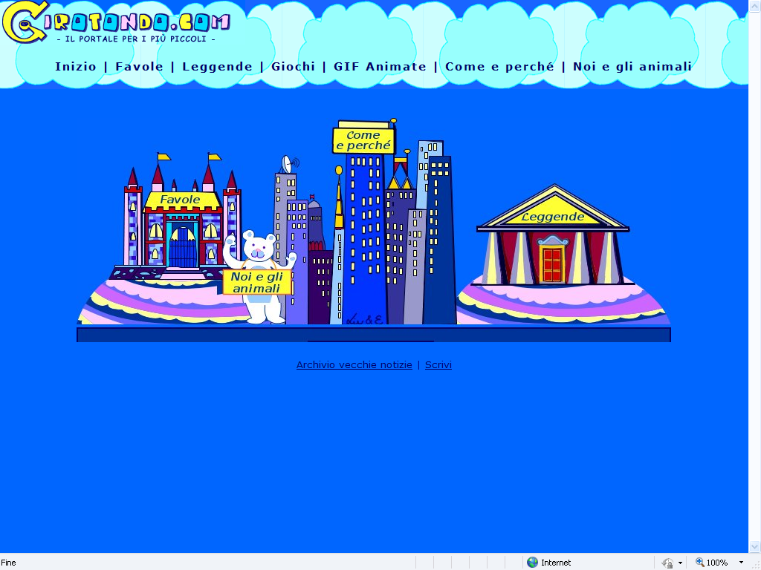
www.babyonweb.com

