During our visit at the theatre called Teatr “Dzieci Zagłebia” we had an occasion to watch the drama “The Wild Swans” by Hans Christian Andersen. These are our pictures drawn after the visit.
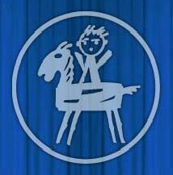
The symbol of the theatre
Teatr Dzieci Zagłębia im Jana Dormana

In February we went to the local theatre called Teatr “Dzieci Zagłebia” . During this visit we were able to watch the drama “The Wild Swans” by Hans Christian Andersen. Screenplay and directed by Krystyna Jakóbczyk.
These are our pictures drawn after the visit. We hope you like them… ☺

And these are pictures of the performance “The Wild Swans”

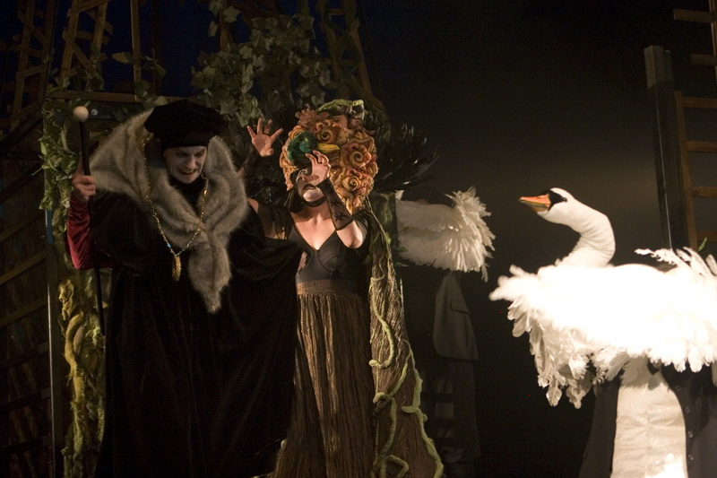
www.teatr.bedzin.pl

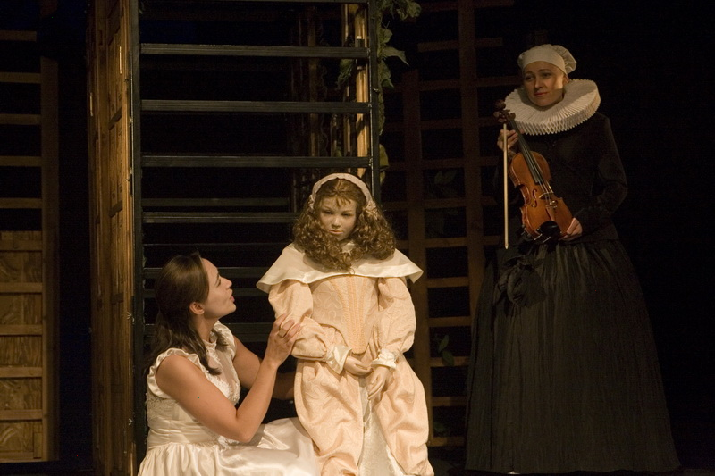
www.teatr.bedzin.pl

www.teatr.bedzin.pl 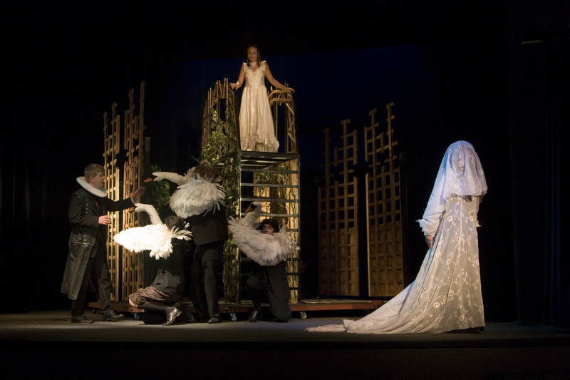
www.teatr.bedzin.pl

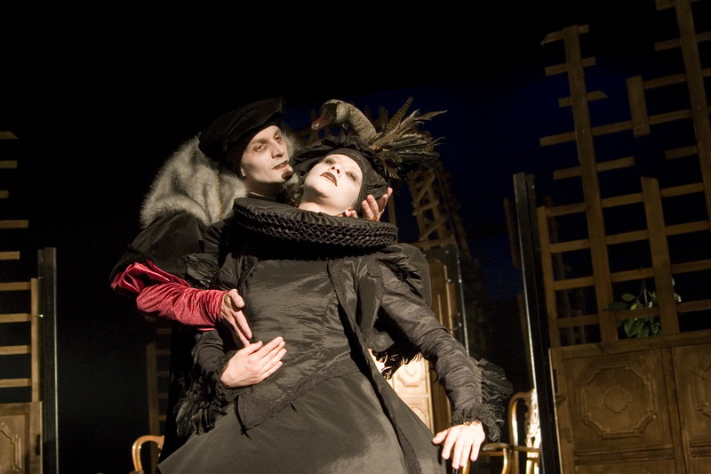
www.teatr.bedzin.pl

We also had an opportunity to watch rehearsals to the new drama “Przygody Rozbójnika Rumcajsa” and meet the director of this drama Mr Kazimierz Mazur. It was a great experience for us!

The first director of Teatr Dzieci Zagłębia was Jan Dorman . He and his wife established their little theatre in 1945. They were meeting children at school in nearest town – Sosnowiec, showing them short performances.
1st April, 1951 the real theater called Teatr Dzieci Zagłębia was established in Będzin.
Since 1996 the theatre has a name of the first director - Jan Dorman. Now its name is: Teatr Dzieci Zagłębia im. Jana Dormana.

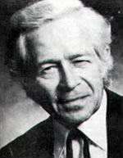
Jan Dorman
If you are interested in our theatre, visit its website: www.teatr.bedzin.pl

