Rutigliano, 18/9/2009

Dear friends,
My name is Rita, I attend the 5th class of primary school “G. Settanni” in Rutigliano (Ba).
I want to express my emotions lived about three weeks ago while I was on holiday in Veneto.
I've been to Venice and visited the Basilica of San Marco and I was impressed by this so big and nice square where there are so many pigeons pecking crumbs, many stalls and shops.
Looking in my showcase, I noticed a gondola bought in Venice and I thought to the emotions people felt when they were inside while making the rounds on the Grand Canal, passing under the Bridge of Sighs.
This trip was wonderful. Venice is a charming city and for me it was very useful to visit it for a greater cultural knowledge.
I greet you.
Hello.
See you soon
Rita

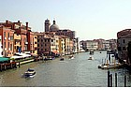 | 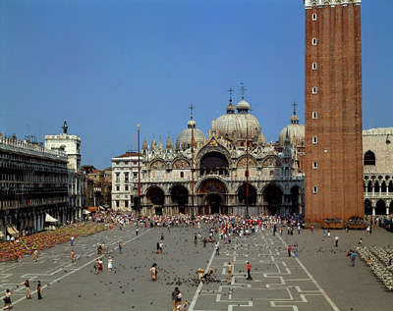 | 