International Children’s Day
Our leader Ataturk loved children and he often said: "Children are a new beginning of our future". 23 April 1920 he opened Turkish Grand National Parliament. Ataturk give this day to children as a present. Ataturk and his friends fought for Turkey. Some of them died but they were very brave. Ataturk saved our country from the enemies. Now everybody in the world know Ataturk.So we need to celebrate this day forever.

How do we celebrate International Children’s Day?
On April 23rd people from many countries from all over give each other presents. Everybody wears their best clothes and shoes. Children present their shows.

Can Tavman/ 5C/ Turkey/ Istanbul

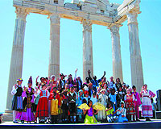

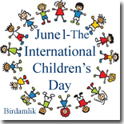
Some with darker hair,
some with lighter hair,
all came to Ankara:
the children of the world.
Every 23rd April
this event takes place.
Explaining the reason
for this gathering is simple.
This wide world
contains many countries.
Yet none of them have
A Children's Day!
The children of the world
flock to our country.
They bustle and fill our country
every 23rd April.
May Turkey be filled with guests
and hearts with love.
To everyone:
A Happy International Children's Day!

