Rutigliano,18/09/2009

Dear friends,
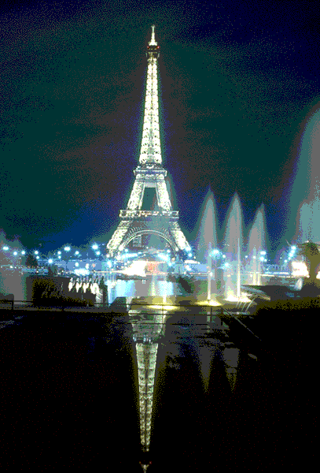
I write you this letter to tell you about my summer holidays spent with my family. I have been in Disneyland in Paris, exactly.
The first day ,as soon as we wake up we were all enthusiastic and with hurry and luggages ready we went to the airport.
I remember with emotion that we arrived to Bari airport with two hours of advance for the check-in, we had breakfast and we embarked.
The flight was spectacular; it was morning and I saw the clouds under me and the things becoming smallerl.
Among a match with the playstation and the lunch served by the hostess I had not realized that it passed an hour and forty-five minutes and that we were almost ready to land to the airport in Paris. We went out to the airport and took the bus that accompanied us to the hotel called “HOTEL SANTA FE”. It represented Mexican decorations and furnishings with a western cow boy theme.
Looking around me everything was very beautiful, we left the luggages and started walking toward the avenue of the entry of Disneyland.
I was really crazy in looking at this immense structure fore children and I thought that I’ d enjoyed a lot.
It seemed to me I was living in another reality, I saw shows, lounges of cinemas, parades of wagons, long avenues and a lot of attractions for children, families and adults.
Among so many attractions that I have visited I liked more “the hollywood tower”.
It consisted in a rapid descent from the sixth floor of an elevator of an old hotel, American style in the the sixties years.
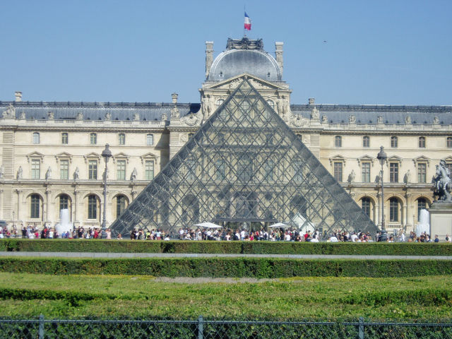
The characters were projected in dressed skeletons.
It has been fantastic and when we will see I will tell you the least details.
I spent three days in Disneyland, we went by taxi to Paris where we accommodate in the hotel “Jofre Mary” situated in the district Operà in the center of the city.
The morning after we had breakfast and we studied an itinerary to visit the monuments.
We took so many lines of subway and in seven days we visited big parts of Paris.
Among all the monuments visited those that impressed me so much were the Eiffel Tower, the arch of triumph, Monmartre , Versailles, the Notre dames and the Louvre Museum.
Dear friends I wrote only a few things because to tell you everything I need a whole book.
When we will see I will tell you everything.
Best regards from your friend Gianmarco.

