Stilton, Geronimo Stilton

Geronimo Stilton is a character that I knew reading a book of bedtime stories my aunt Cecilia gave to me. Ours was love at first sight: from that moment I started reading his books.
Geronimo Stilton was born in Topazia "on the Island of rats", he is the director of a newspaper:” the Echo of Rodents”. His life is not simple :he is always engaged in hard work, extreme adventures, mysteries ...
He is also a secret agent, a golf player, a football fan and his favorite team is the Rattonia. His family is very large: he has a sister named Tea, a cousin named Trap and a grandson named Benjamin.
The book that impressed me most was: "Fourth trip to the Realm of Fantasy" that is part of the series for boys, "the Steamboat." It tells of the mysterious disappearance of the last dragon egg that if it didn’t open out dragons could vanish.
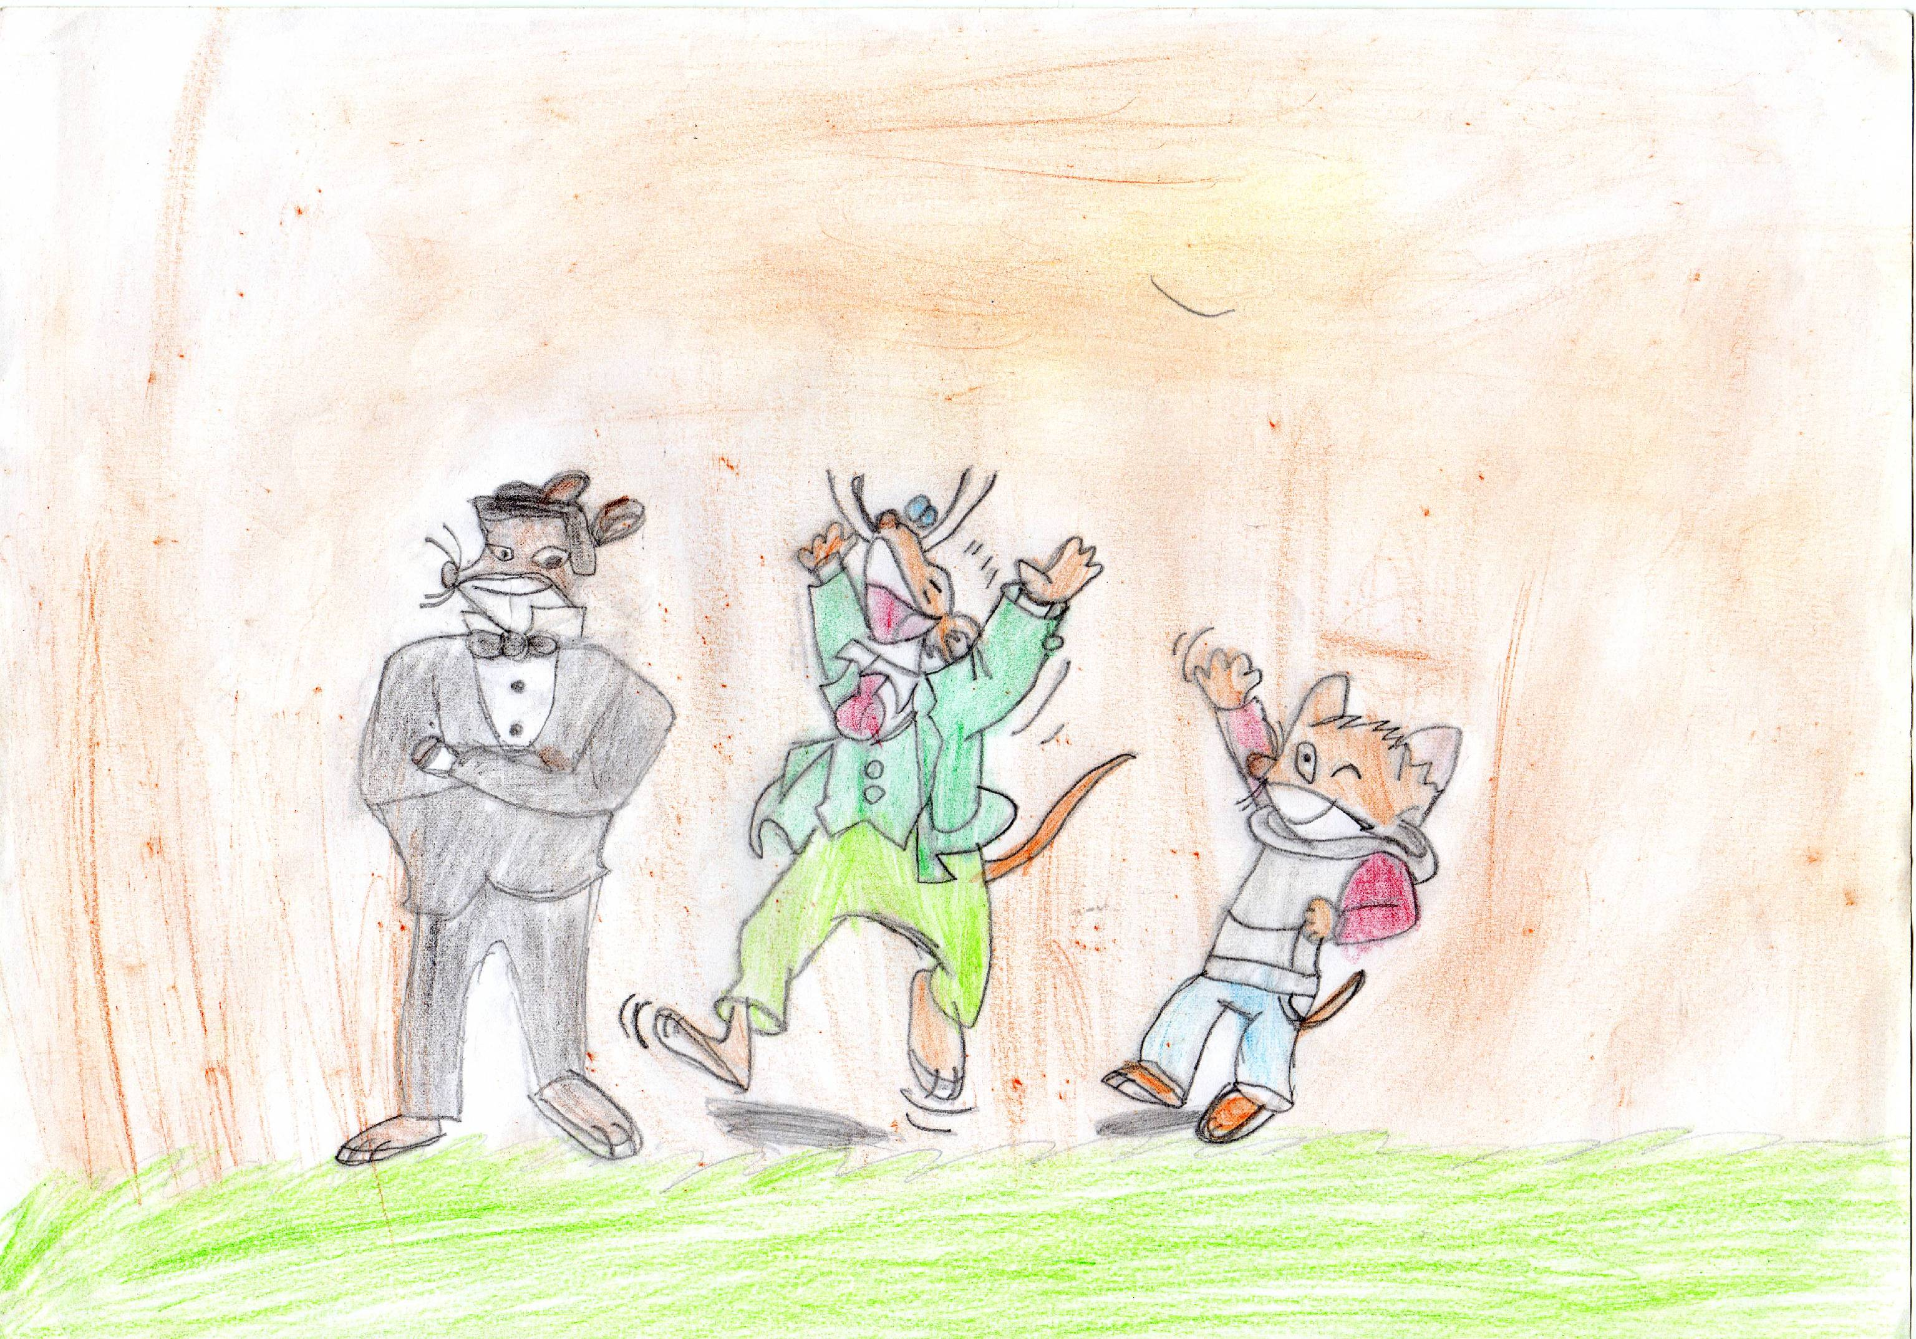
The twelfth knight, G. Stilton, strong and courageous, helped the Silver Dragons , and the Fire dragons to find the last dragon's egg .He found it in the cave trolls and protected it during a violent battle that sees the silver dragons and the gnomes against the fire dragons and the black knights .
I hope you get the idea of this character ultra adventurous and I hope to meet another character who attracted my attention by involving me totally and forgetting all that was around me.

