My Favourite Character
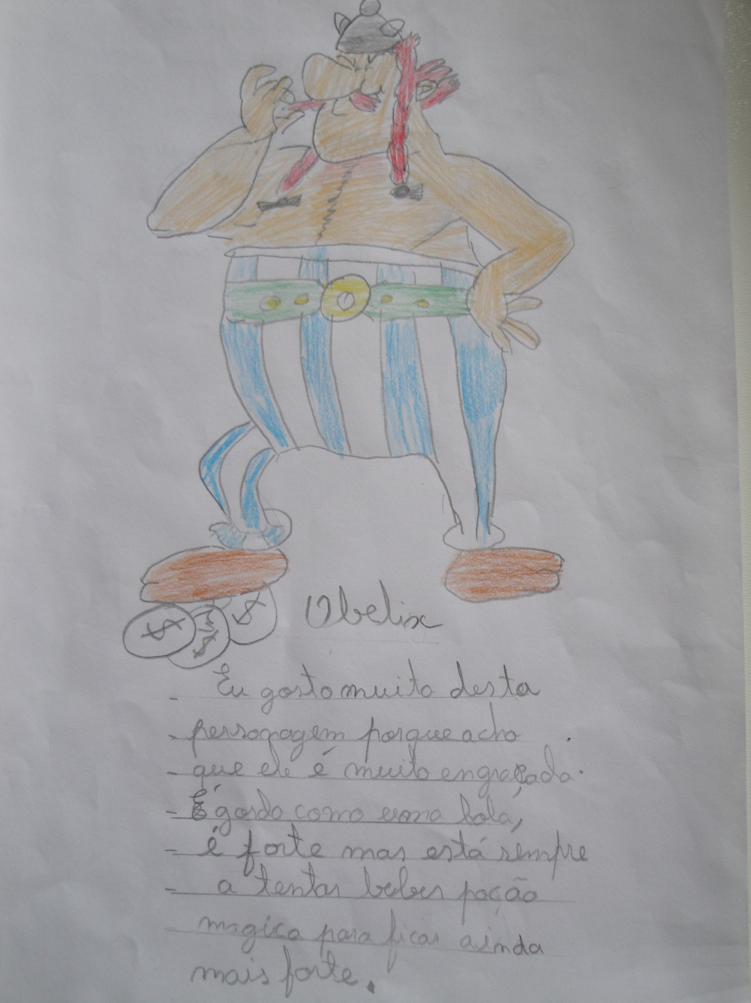

OBELIX
I like this character because he’s funny.
He is fat like a ball and strong and he is always trying to drink
the magic potion to be more strong.

