Kasia Sołtysek
Class 4a

“Bułeczka”

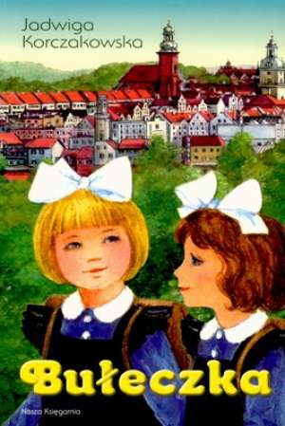
My favourite book character is Bronia, who has round cheeks and that’s why is called “Bunny” ( Bułeczka) . She is the main character from the book “Bunny” written by Jadwiga Korczakowska, the Polish writer.
Her parents died. She stays with her grandma and lives in the small village. When her grandma become ill, girls have to stay with the uncle.
The Bunny, however she is only eight go for the trip to the further city. And this trip she treats as a nice adventure.
She always tries to think positive way and the good way about everything what happens to her. She is happy because she is going to met her new uncle and aunt. She is happy because their daughter will soon become her sister. Unfortunately Wanda isn’t a nice girl. She is capricious, weepy and cannot find to herself any good play and that’s why she always feels bored. She is a spoiled by the housekeeper Margaret, because her mum works in the theatre in a city. The new Bunny’s family is rather rich however in this time there was no computers and Barbie dolls. Wanda has many nice toys but Bunny is not allowed to play with them. At the beginning Wanda doesn’t want to play with Bunny. She is laughing because of Bunny’s old and ugly clothes. Bunny hasn’t got neither nice clothes nor toys but she is happy. Her toys are : the beads made of rowanberries, a beautiful shell that hums when put it next to her ear and the magic doll “Czroduszka”, made of old rags. But Bunny believes that this little doll brings luck not only to her but to everybody.
Bunny is delighted with small things: because she got a mug, or that uncle and aunt have a dog called Trezor and they allow her to with him. She is delighted even with grey sparrows sitting on the fence.
She never lies, never says any bad words, never complained. She tries to help to everybody. She can tell beautiful stories.
I would like to have such a good friend as her.

