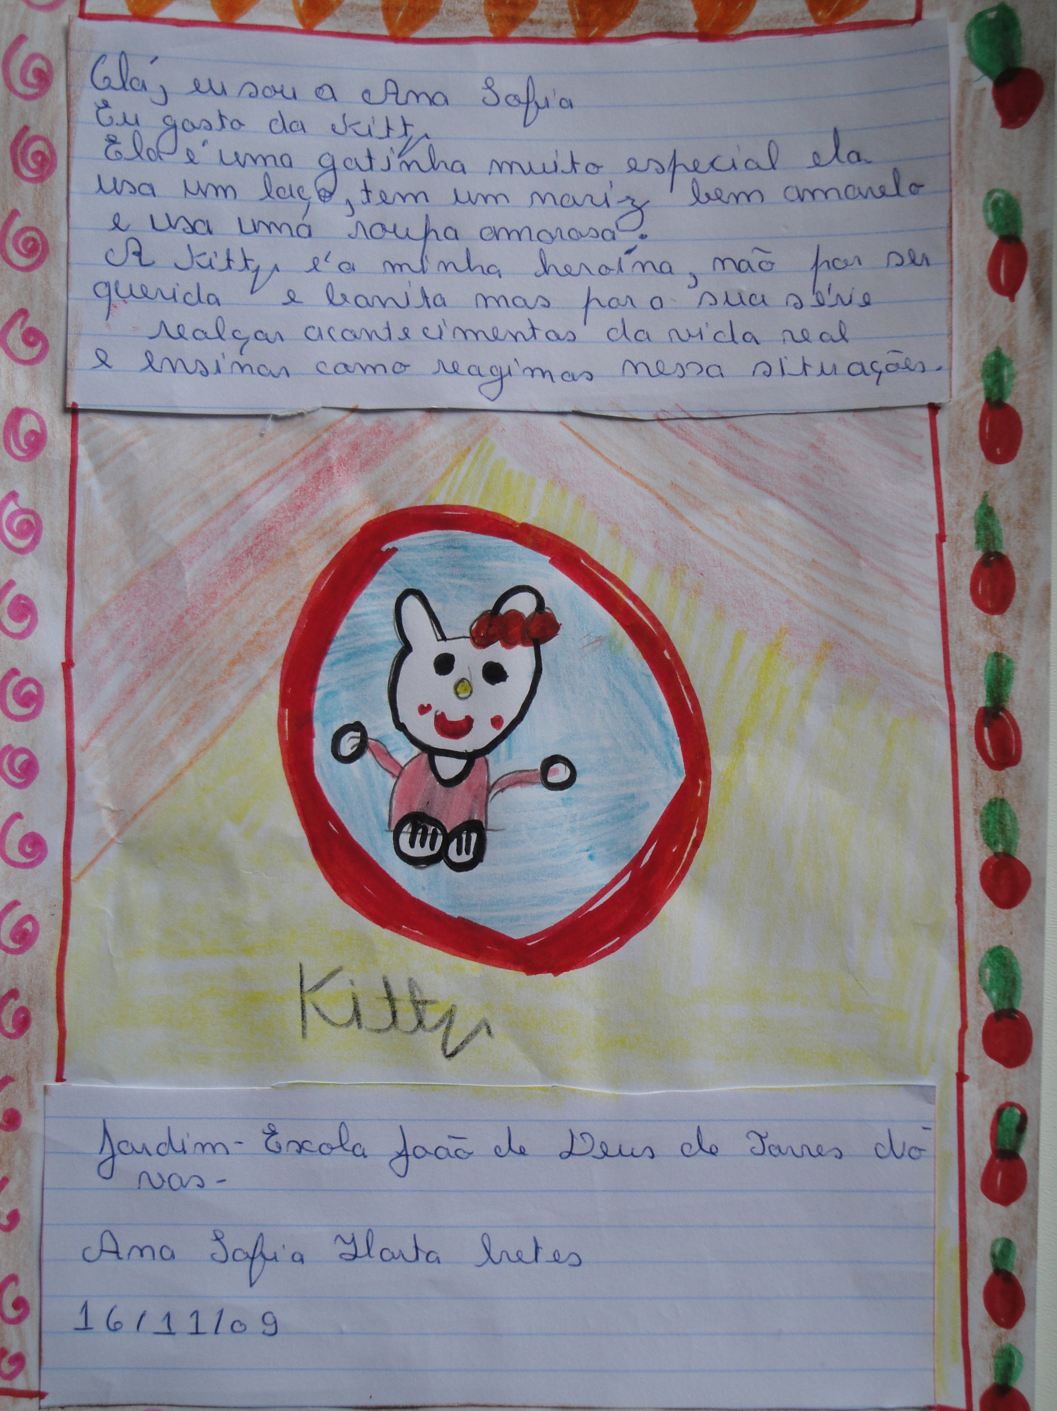
My Favourite Character

Hi! I’m Ana Sofia.
I like Kitty. She is a special kitten. She’s got a bow tie and she’s got a yellow nose.
She wears lovely clothes. She is my hero not only because she’s sweet but because in the TV series, she helps us with real life situations.
I love Kitty.

