Rutigliano, 21/09/2009
Dear friends,
This summer has been incredibly fantastic. With my family I went to the mountains in Levico Terme which is located in Trentino, where there are the Dolomites, the most beautiful mountains in Italy.
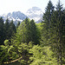
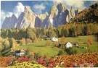

When I left, I was excited, happy, but the idea of making a long car trip a bit 'bored me, but I knew that this time would be pass immediately.
When we arrived there, I jumped for joy. Around me there was only so much green and colourful flowers; it was beautiful. The mountains in the background seemed to look at us quiet.
The hotel was large enough, a bit luxurious, with many rooms and a swimming pool, with so many people who were swimming , a soccer field, tennis, bowling and a playground. Our room was on the third floor. I closed my eyes because it was a surprise and when I opened I saw a beautiful room.
The following days I went to Gardaland, an amusement park on Lake Garda. A flood of fun on all merries –go- round. I went on the flying saucer and from the top you could see a beautiful landscape, to remain open-mouthed. From there the Lake Garda was great.
At that moment I wished you were there too, so we'd have enjoyed even more.
I hope that you too have spent a beautiful summer. Let me know your news soon.
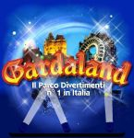
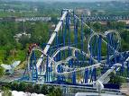

I greet you with love
Constance

