Rutigliano 17/09/2009
Dear Giada, In September I went on vacation near the lakes Alimini in the residence Bravo.
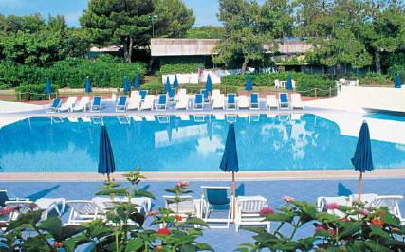 | 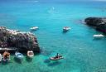

The sea was clear and the thing that struck me most was the black sand beach. The pool was great and I enjoyed diving. If you were there you would have made some swimming competitions. The buffet was very rich, I took a lot of food that I didn’t eat. You would have done great blows-out of desserts because I Know you are very
greedy. I went to Otranto to visit the castle and the cathedral where there were eight hundred skulls of martyrs killed by the Turks.

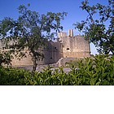 | 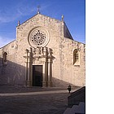

Even Lecce with its baroque churches was very beautiful. 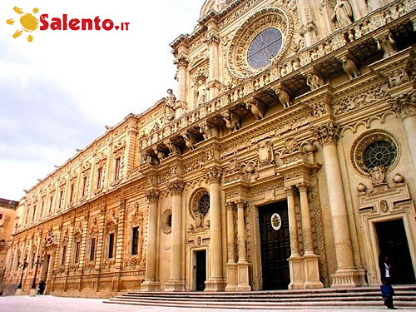
A guide told us much about the history of the city.
Giada ,I want to spent with you next holiday. I hope that your parents will let you come. We’ll have a great time. I hope that you’ll answer me soon. I send you many kisses
Your Antonella

